Visit the CESC Website through the link https://cescmysore.karnataka.gov.in
Step-1
CESC Website
Registration procedure for installation of rooftop solar plant through CESC Website
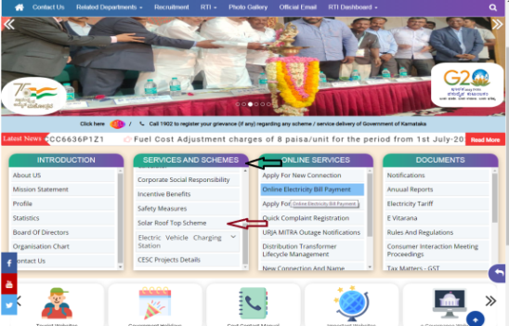
Step-2
Services and Schemes

Step-3
Solar Roof Top Scheme
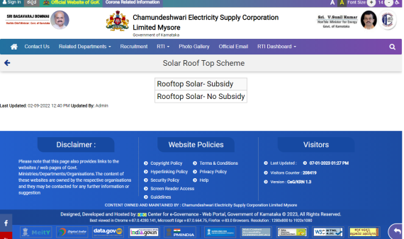
Step-4
Roof top – Subsidy

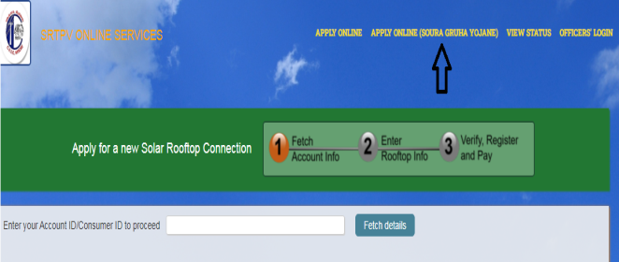
Step-5
Apply Online (Soura Graha Yojane)

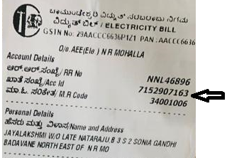
Step-6
Enter Account ID/ Consumer ID

Details required for registration
- Latest Electricity Bill
- Aadhar copy
- Pan Card
- Photo
- Lattitude & Longitude details
- Mobile number
- Email ID
Step-7
Register the application

Acknowledgement will be received through SMS and Mail.
Step-8
Acknowledgement
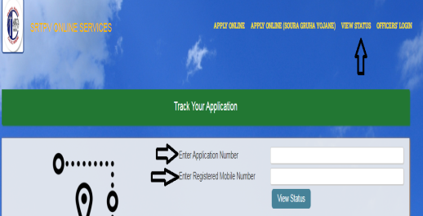
Step-9
To check the Status of application

